**BEEE EXPERIMENTS LAB FILE**

Experiment 6: Designing an automatic night lamp

Circuit diagram:

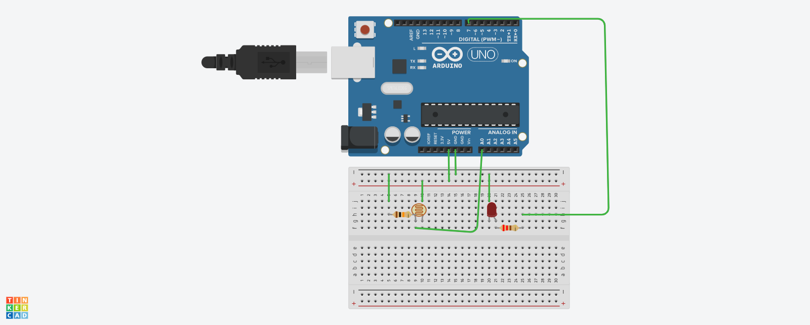

**THEORY**

**CONCEPTS USED:**

1. Uses of Arduino.
2. Concept of Serial.begin(9600)
3. Connection LED'S to ARDUINO board.
4. The use of Light dependent resistor.
5. Using if and else statements in coding.
6. Using appropriate resistances for both the LED and the Photoresistor.

**LEARNING AND OBSERVATIONS:**

1. The use of Serial.begin(9600).
2. Resistance of 10k ohm is needed for LDR.
3. The importance of having analog pins in Arduino as LDR is connected to analog pin.
4. Learnt about the use of if- else statements.
5. The LED needs to be in forward bias.

**PROBLEMS AND TROUBLESHOOTING:**

1. Improper connection to the power pin was made and it was solved after making proper connection.
2. The circuit was incomplete because a wire connection was missing.

**PRECAUTIONS:**

1. LDR needs to be connected in Analog pin.
2. Reverse bias of LED'S can damage them.
3. Faulty code will lead to the LED not blinking.
4. Make sure the connections are appropriate .
5. The use of brackets and pinMode needs to be correct otherwise the code won't work.
6. A high value resistance needs to be connected with the LDR.

**LEARNING OUTCOMES:**

1. Improper resistance value can lead to faulty working.
2. I learnt about the practical usage of LDR.
3. Practical use of if-else in coding.
4. Now I have enhanced and improved knowledge of breadboard connections.
5. The importance of analog pins in ARDUINO.